Remind

Tired of finding newsletters crumpled in the bottom of a bookbag or the last minute, “Tomorrow is…” from your child? Ms. Kendall’s got the solution!

****Note: This is my “newsletter!” All class information will be shared via Remind text, email or the app. I will need all parents/guardians connected. THANK YOU! You will love this communication!****

Remind provides a safe way for teachers to mass-text message parents to stay in touch.

I am using this app to help you stay informed for things going on in our classroom. Basically, Remind allows me to send a one-way, mass text to your phone or email address to keep you aware of up coming events, homework, schedule changes, and other school related events. It is completely anonymous and no cell phone numbers or email addresses are shared.

Follow the instructions on the back of this page for how to sign up. It’s that simple! Once you subscribe, you are all set to receive messages. I know you will love this easy way to stay connected!

Remind will be connected to my website: http://mskendallpr.weebly.com

How to Sign Up for Remind:

Easiest Way to Start (Just Texts):
- Open new text.
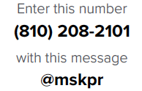

- Send the text.
- You’ll receive a text.
- Reply with your Child’s First and Last Name.
- Send the text.
- You’ll receive a text saying you are in Ms. Kendall’s class.

For the Smartphone Savvy
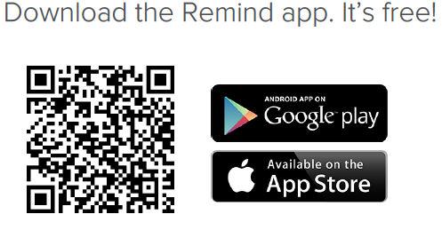

- Follow the on-screen prompts.
- Please remember to use your Child’s First and Last Name here, too.

